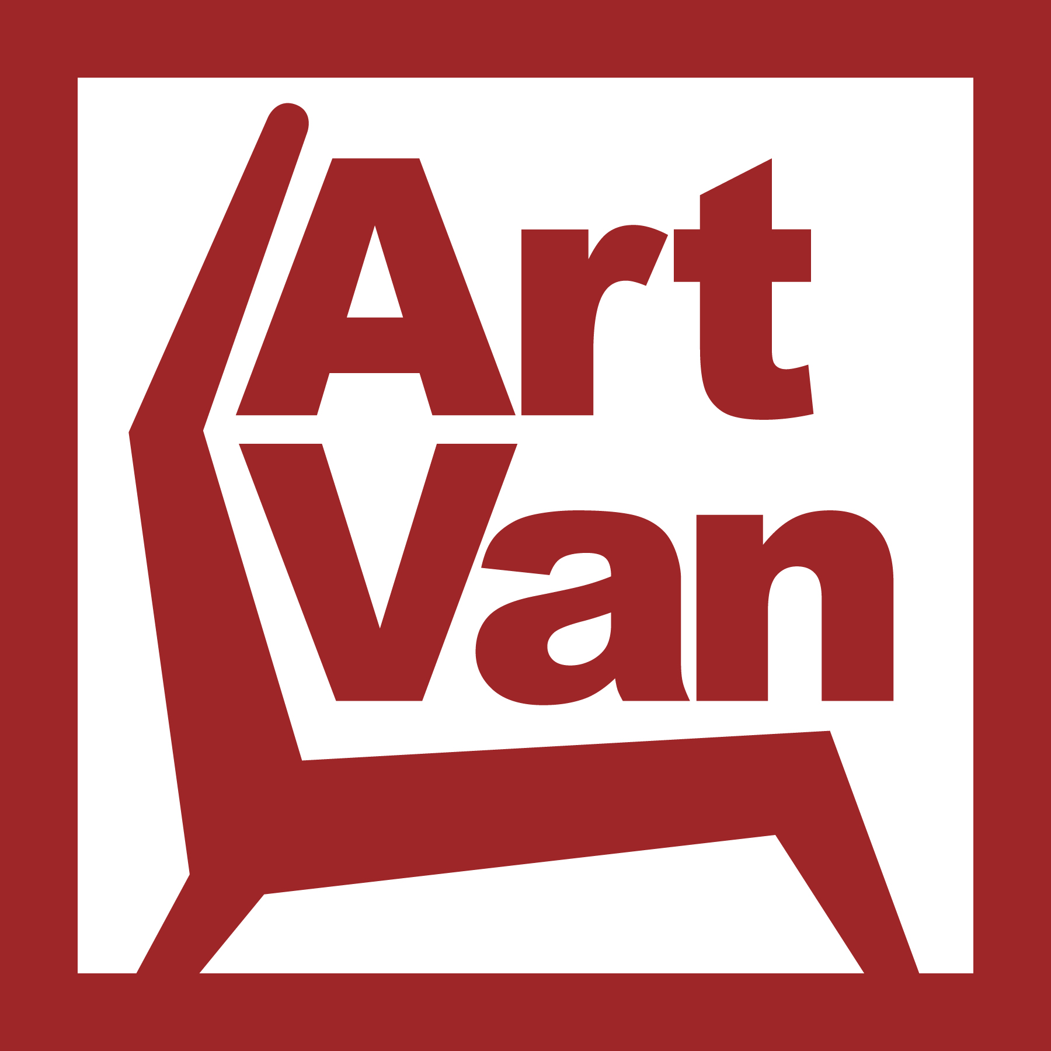
Art Van Furniture
Project Planning Template

- Summary of Project Information

Project Name: Artvan.com 3.0

Summary Description: The purpose of Artvan.com 3.0 is a 3 pronged approach in delivering the ability to become a $50 million dollar store within Art Van Furniture. All aspects of the project will be done in parallel with each other and consist of these 3 main areas which form the basis of our Art Book Goals. 1) Infrastructure upgrade which will allow the traffic to be able to navigate and shop artvan.com 2) Mobile first website design which will allow our guests to have an Art Van Experience no matter what type of device they are visiting from and 3) Commerce first approach to the website allow guests to purchase through their preferred shopping channel.

Project Leader: Brad Chuminatto Project Sponsor(s): Amelia Ellenstein
Jeff Bowers Jim Higgins

Team Members: | Roles & Responsibilities:
Heather Boddy | Artvan.com and mobile design expert
Jeff Bowers | Artvan.com IT expert
Brad Chuminatto | Artvan.com expert
Resource Ammariti | Third party design/development team
Perfecent | Third party IT team

Project Start Date: 03/14/16 Completion Date: 01/30/16

Last Revision Date: 02/29/16

2. Introduction, Opportunity, Objective & Scope
A. Introduction: artvan.com will position Art Van Furniture as a leading retailer of online transactions and help transform artvan.com into a flagship store that is capable of delivering $50 million in business. The 3 main areas in this project are 1) infrastructure 2) mobile and 3) commerce abilities.

B. Opportunity: Ability to drive more traffic and support more guests on artvan.com regardless of the device or way our guests would like to shop artvan.com

C. Objectives: (1) Increase sales (2) Add infrastructure for support of $50 MM

D. Scope: This project will impact: (1) Web (2) IT (3) Sales.

3. Assumptions & Risks
Assumptions: (1) All in-store digital shopping interfaces will use one experience. This solution will provide a single interface for all Art Van and vendor supplied “endless aisle” product to be accessed in-store. (2) The experience will be driven by the AS400 and the web (3) The interface will connect the web to in-store and leverage Room Service account information and benefits (4) The project will enhance the selling experience for Sales Associates and the buying experience for Guests. (5) Sales team members will be able to commission for sales placed on the kiosk (6) …

Risks: (1) Very few retailers have similar technology in place – are we at risk as an early adapter? (2) The sales team may not accept the innovation due to fear of competition with web. Adoption by the sales team is critical to success. (3) The sales team, who is not known for being tech savvy, may not be comfortable with the technology (4) PureSleep sales team members may not be comfortable selling furniture with a web-style interface (5) Technology may not always function, creating a negative experience and impression for the guest (6) Bandwidth has the potential to constrain functionality.
4. Resource Requirements & Cost

Description: | Cost
Total Cost

5. Benefits

Description: | Benefit
Total Benefit | $

6. Post Plan Success Measurements

Key Performance Indicator | Current State | Target

7. Major Project Milestones

Description: | Target Date

8. Project Approval
Project Sponsor:
Date:

Signature: ___________________________________

*All Project Plans must have a Project Action Register Completed. See next page (3 of 3)

Project Action Register

Project Name: Description:

Project Leader: Team Members:

Project Sponsor(s):

Project Start Date: Completion Date: Last Revision Date:

Task List
Number | Deliverable | Description | Owner | Due Date | Status | Comments
1
2
3
4
5

